Project over view


Summary of the Project finding
Top Performer: Store (20) has the highest grossing location by 301397792 $
The Holiday Peek: Sales during holiday weeks has 52% from total Sales
Weather Impact: from the record I found that the less the Temperature is the higher the Average Sales
Economic Resilience: When Unemployment rate increase the Sales drop significantly.
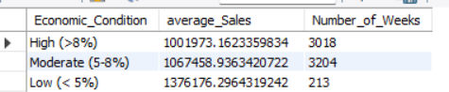
EDA Results
The highest total sales for the records time scope is July by 650000977$
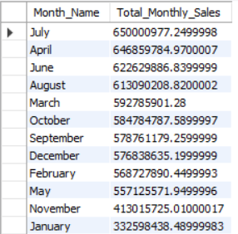

Peak month
December has been the peak month for two years in a row by 288760532$ and 288078102$ for 2010 and 2011 respectively unfortunately December 2012 is missing from the records but I expect it has the highest sales as the prior year because of the holiday season,
However the records show that 2012 peak month is June by 240610329$ total sales
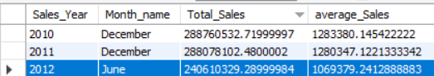

Slowest Month
Disclaimer 2010 January is missing from the records, I mentioned this point because I expect January is the slowest month of 2010 but unfortunately I don’t have the data that support that claim
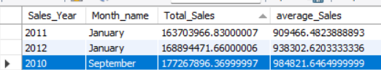
However the records show that the slowest month is usually January in 2011 and 2012 except in 2010 was September

Temperature Causation to average revenue
As we see in the table below that the average revenue has an inverse relationship with temperature
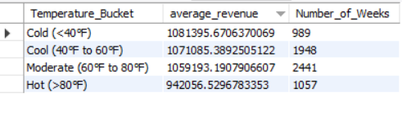
As the temperature decrease the average revenue increase that could be because of the holiday season

The highest grossing location
The results shows that store (20) came on top in the total sales and store (4) comes next by 301397792$
And 299543953$ respectively
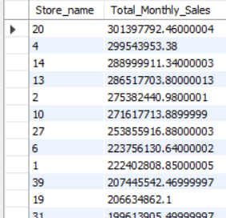

Holiday effect
Sales during holiday weeks were approximately 7.8% higher than normal weeks as shown in the table below
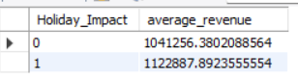

Top Performer
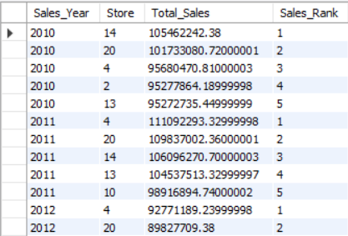
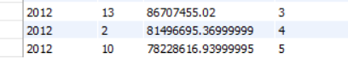
As we see on the table the top 5 store branches across the three years of the data used in the analysis,
In 2010 the top 5 was (14,20,4,2,13) and for 2011 the top 5 was (4,20,14,13,10) and for 2012 was (4,20,13,2,10) from the results we discover that some branches stayed in top 5 consistently like (4,13,20) another point I like to discuss that 2011 all top 5 outperform and make it the best performance year in sales.

